AGTS SPRING LECTURE!
FRIDAY, May 5, 2017 10:00 AM
Samuel S. Fleisher Art Memorial
719 Catherine Street, Philadelphia, PA 19147
Discover this Historical Hidden Gem! The Oldest Community Art School in America.
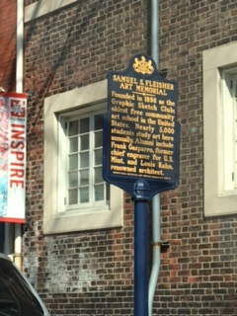
A lecture on the history of the FLEISHER, Graphic Sketch Club, historic buildings, collections and the children & community they serve followed by a tour of the current exhibit and classrooms.
The Da Vinci Art Alliance across the street will be exhibiting “Crossing Boundaries” An international postcard Open Call combined with group exhibition of 6 immigrated local artists, a small intimate two part exhibition. Both exhibits are free to AGTS Members

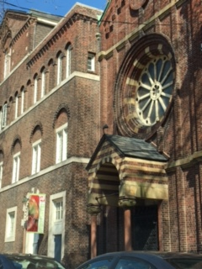
Catherine Street is a one way street that you will need to approach from 7th street. Classes are not held on Friday, which will provide ample free parking to AGTS members in the faculty & student lot. (left side of street) Enter through the main entrance on the right side of Catherine for access to the exhibit and Sanctuary.
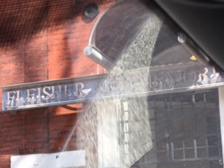
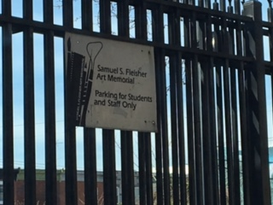
Parking Main Entrance Sanctuary

